 

**Placement Empowerment Program**

***Cloud Computing and DevOps Centre***

Host a Static Website Locally: Set Up a Local Server Apache and Host a Simple HTML page with your name

Name: VIJAYA NANDANA M Department : CSE



**Introduction and Overview**

In this POC, we will learn how to host a static website locally using the Apache HTTP Server. This process involves setting up a local web server with the help of command prompt by configuring it correctly, and hosting a simple HTML page. By following these steps, you’ll get hands-on experience with configuring and running a local Apache server, which is a foundational skill for web hosting and server management.

**Objective**

The goal of this project is to:

1. Set up a local web server using Apache.

2. Configure the server to host static files.

3. Create and host a simple HTML page displaying your name.

**Importance of Local Hosting**

Local hosting is an essential skill for developers, as it allows them to test and experiment with web applications in a controlled environment. It offers several advantages, such as:

**Step-by-Step Overview**

Step1:

Search for "Apache Lounge" on Google and click the first link to access the official website.

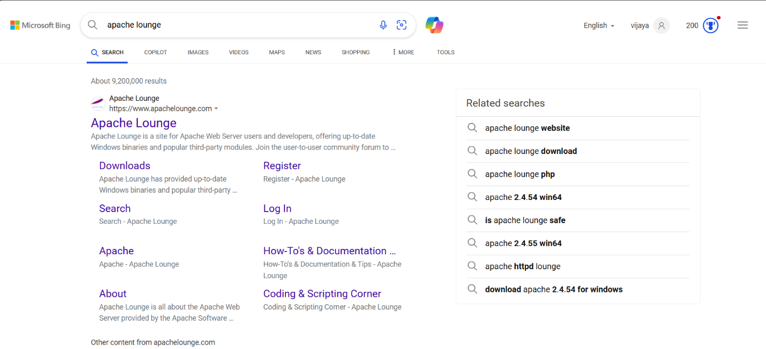

Step 2 :

Click on the "Downloads" option located on the left-hand side of the Apache Lounge website. Click on the link **"Apache 2.4.62-240904 Win64"** (Windows version), download the file, and extract all its contents.

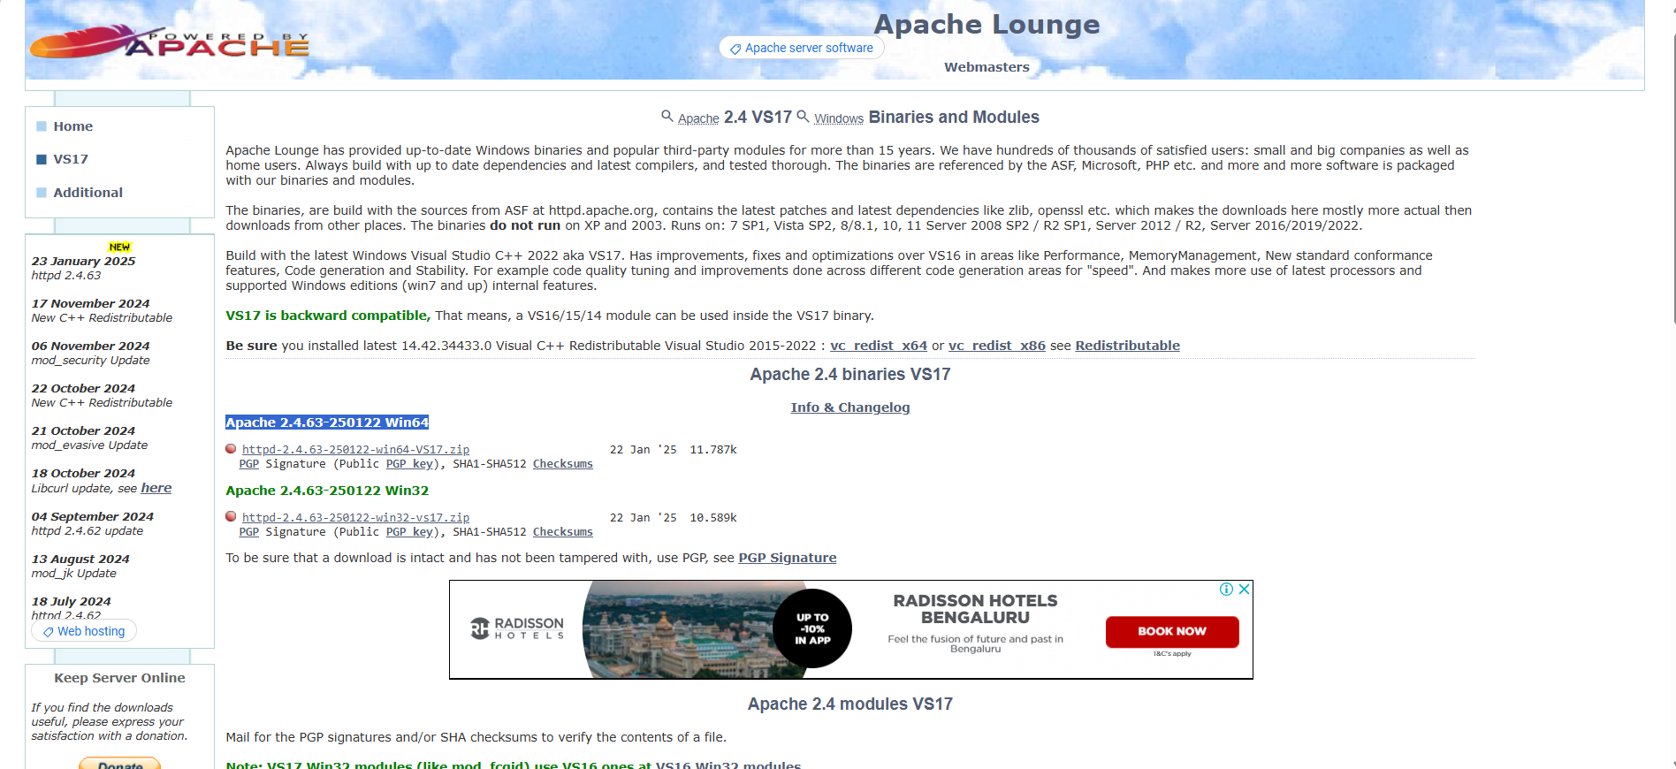

Step 3 :

Open Command Prompt and use the command cd <file path> to set the path to the Apache bin folder.

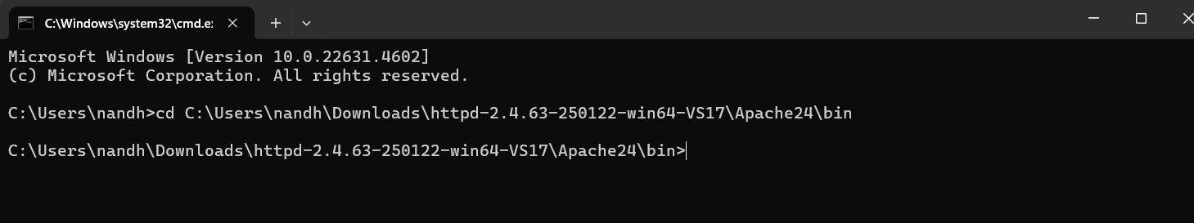

Step 4 :

Then Run the command **httpd.exe -k install** for installation of Apache server



Step 5 :

* Navigate to the Apache folder you downloaded.
* Go to the **conf** folder
* Right-click on the **httpd.conf** file. Select 'Edit with Notepad'.

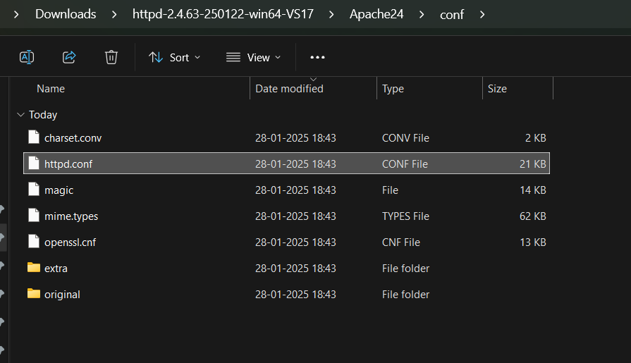

Step 6 :

Inside the **httpd.conf** file, replace the content with the provided configuration. Ensure you update the SRVROOT directive with your Apache installation path.

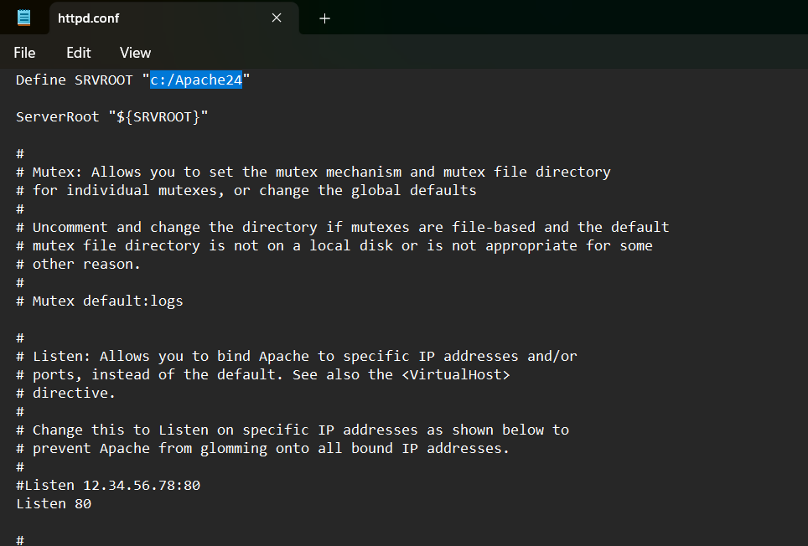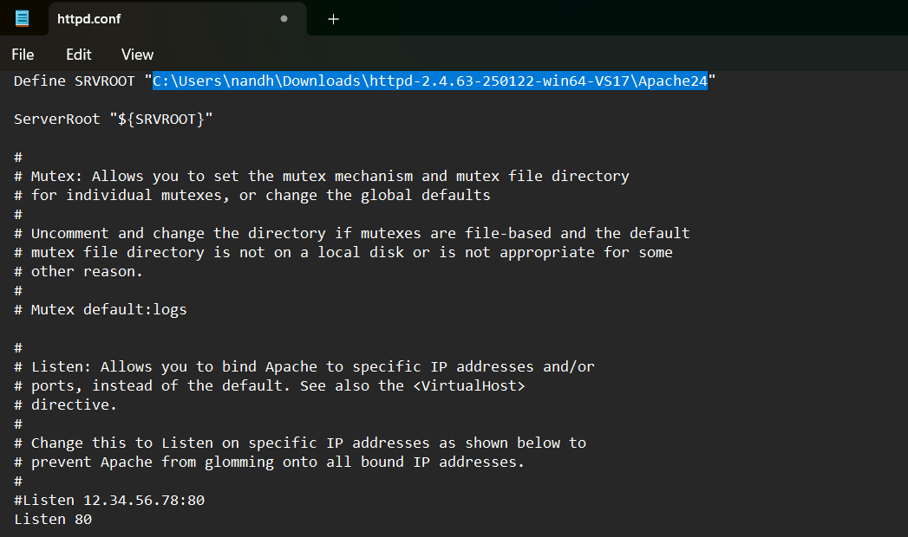

Step 7 :

In the cmd terminal type the command **httpd.exe -t** to test the configuration file. If the configuration is correct, you will see **'Syntax OK**'.



Step 8 :

To start the Apache server, type “ **httpd.exe -k** ”.



Step 9 :

* Go to the Apache folder.
* Navigate to the **htdocs** folder.
* Go to the **index.html** file. Right-click on it and select 'Edit with Notepad'.

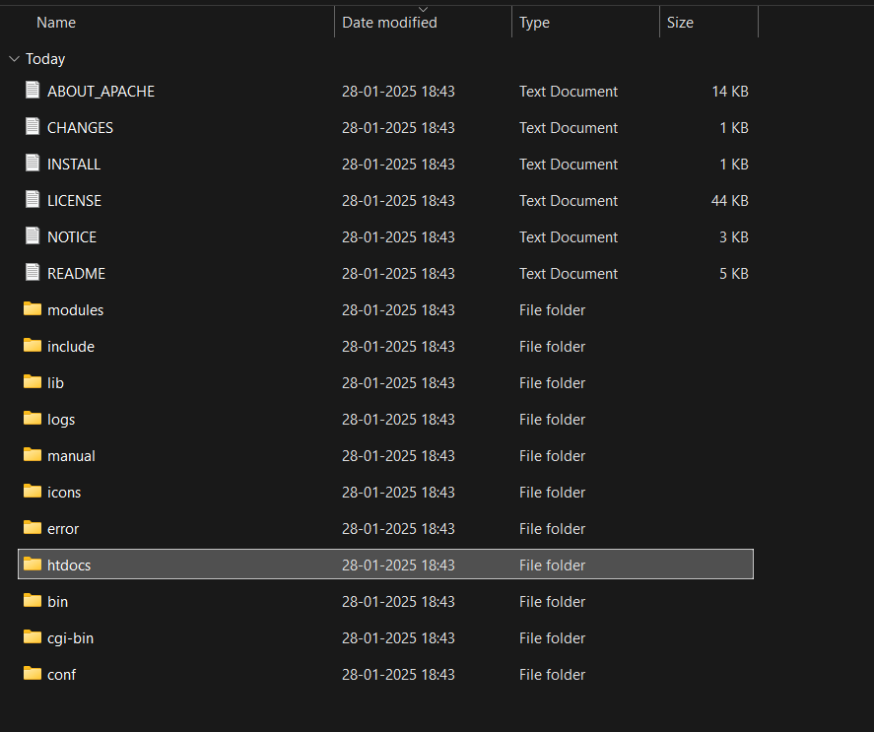

Step10:

Create a simple model to display your name in HTML.

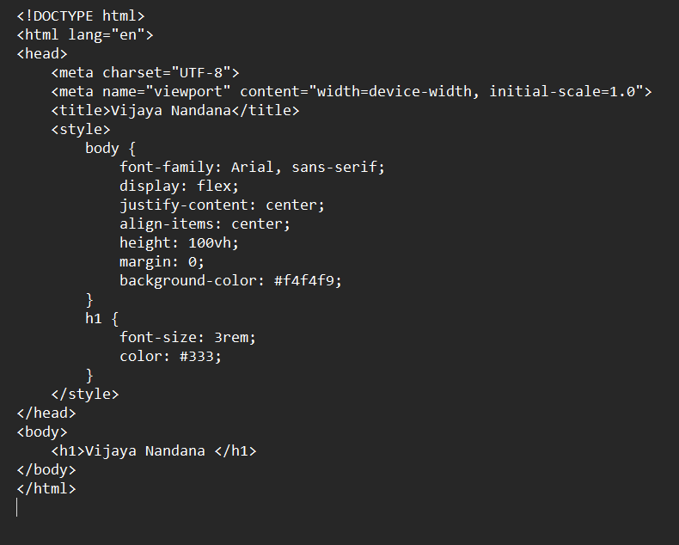

Step 11 :

Open the Chrome browser and type **localhost/index.html** in the address bar. You should be able to see the website hosted successfully.

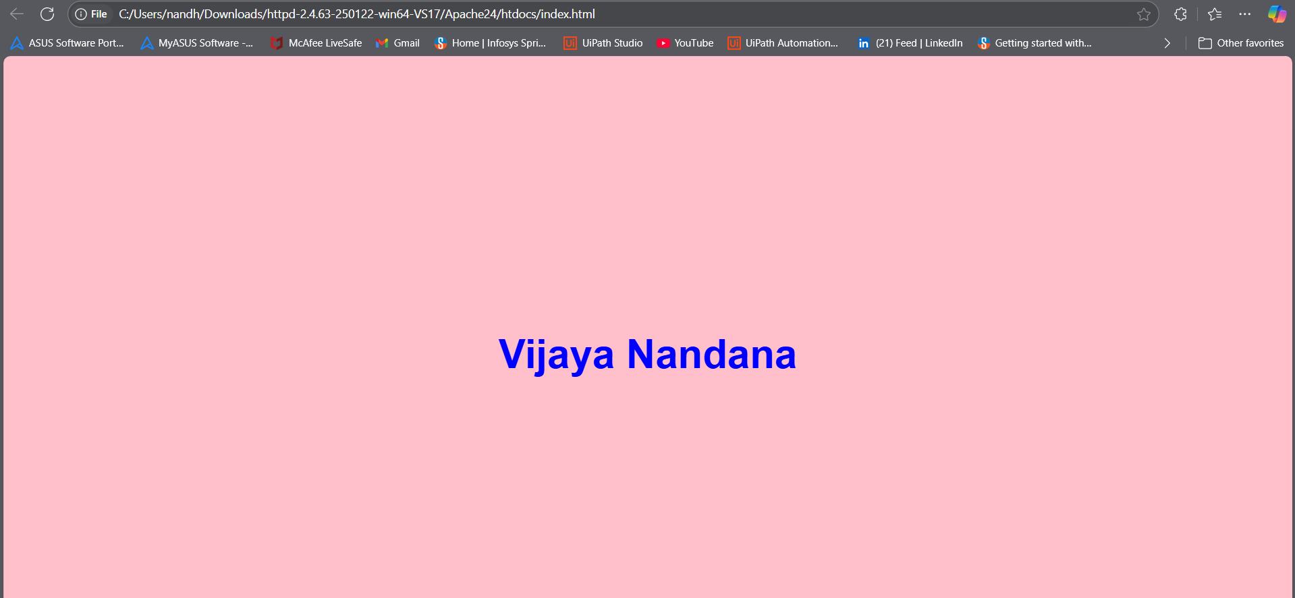

**Outcome**

By completing this POC, you will:

1. Successfully configure and run an Apache server locally.

2. Host a static HTML website that displays your name.

3. Understand the basics of web server configuration and file hosting.